**Lesson 1 Getting Started with Arduino**

1. Preface 1

2. About Arduino IDE 1

2.1Features of Arduino IDE 1

3. Install the Arduino Software (IDE) 2

4. Install the CH340 driver 8

Method 1 9

Method 2 12

5. Any questions and suggestions are welcome 14

# Preface

If you have already installed Arduino IDE on your PC and have some experience with arduino, you can skip this chapter.

# About Arduino IDE

Arduino IDE (Integrated Development Environment) is a software designed for Arduino hardware development, providing an easy-to-use graphical interface that allows users to write, edit, compile, and upload code to the Arduino development board. The goal of Arduino IDE is to simplify the programming process, making it easy for both beginners and professionals to develop microcontroller applications.

The Arduino IDE contains a text editor for writing code, a message area, a text console, a toolbar with buttons for common functions and a series of menus. It is a cross-platform application for Microsoft Windows, macOS, and Linux.

## 2.1Features of Arduino IDE

**Simple user interface:** The interface of Arduino IDE is simple and intuitive, including a code editor, compiler, serial monitor, and other debugging tools.

**Code highlighting and auto completion features:** The editor supports syntax highlighting and auto completion, helping users write code faster.

**Cross platform:** Arduino IDE can run on multiple operating systems, including Windows, macOS, and Linux.

**Open source:** Arduino IDE itself is software based on open source, mainly written using components such as Java, Processing, and avr gcc.

**Wide hardware support:** Although primarily designed for Arduino hardware, Arduino IDE also supports other compatible microcontrollers and development boards.

**Programming Language:** Arduino IDE uses a simplified version of a C/C++based language called Arduino Language or "Sketch", which provides some predefined functions and libraries to simplify common programming tasks.

**Serial port monitor:** The IDE's built-in serial port monitor can be used to send and receive data, which is very useful for debugging code and real-time viewing of device status.

**Community Support:** Behind Arduino IDE, there is a vast community that provides rich tutorials, sample code, and forum support.

**Scalability:** Users can extend the functionality of the IDE by installing additional libraries and core files, supporting different hardware and features.

**ISP online burning:** Supports In System Programming, allowing direct programming of microcontrollers on Arduino boards through USB interfaces.

# Install the Arduino Software (IDE)

You can visit this link: <https://www.arduino.cc> to install the latest Arduino software (IDE)

Install the Arduino Software (IDE) on Windows computer Refer to: <https://www.arduino.cc/en/Guide/Windows>

Install arduino IDE on macOS System computer Refer to: <https://www.arduino.cc/en/Guide/macOS>

Install arduino IDE on Linux System computer Refer to: <https://www.arduino.cc/en/Guide/Linux>

[Portable IDE](https://www.arduino.cc/en/Guide/PortableIDE) (Windows and Linux)

Refer to: <https://www.arduino.cc/en/Guide/PortableIDE>

**Here we detail how to Install the Arduino Software (IDE) on Windows PCs**

The Arduino IDE 2.1.1 is the latest Arduino Software for Windows when we write this tutorial.Because the official version will continue to be updated, it is possible that when you see this document and log in to the Arduino official website, the latest version of the Arduino IDE may no longer be 2.1.1, but a higher version. So this document is for you as an example to download the Arduino IDE as a reference.

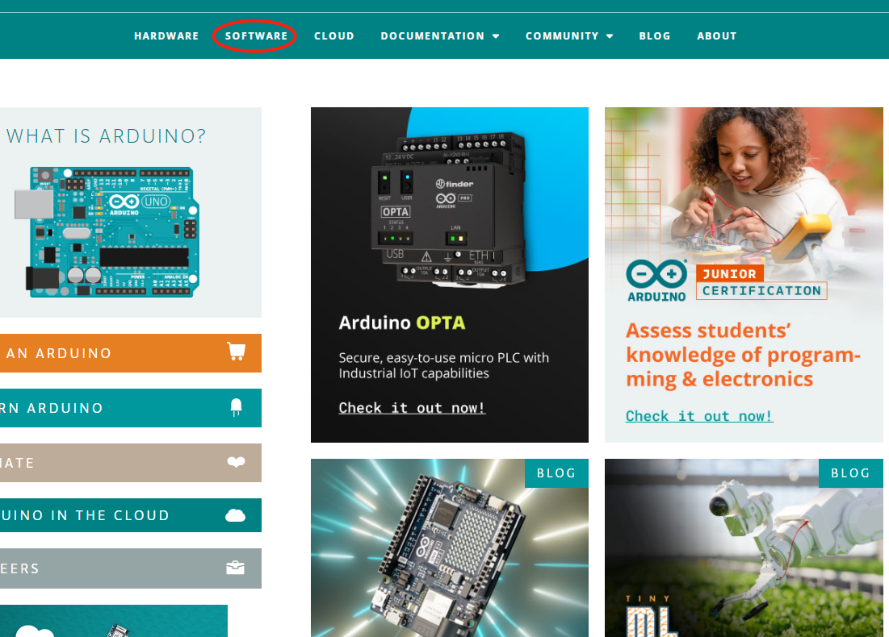

Visit this link: https://www.arduino.cc go to the Arduino official website page,click the menu bar SOFTWARE on the home page to enter the download interface. Then select and download the corresponding installer according to your operating system.

This document explains how to install the Arduino Software (IDE) on Windows machines. There are three Windows installation version options in the "DOWNLOAD OPTIONS" of the "SOFTWARE" interface.

 Support Win10 and newer 64 bits windows system

 Arduino IDE Windows Installer (.exe)

 Arduino IDE Windows Zip package(Free installation)

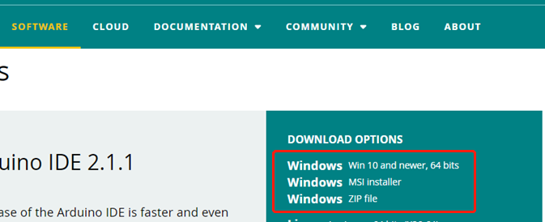

We take the Arduino IDE Windows Zip package(Free installation) as an example, to explain how to use the Arduino Software (IDE) on Windows

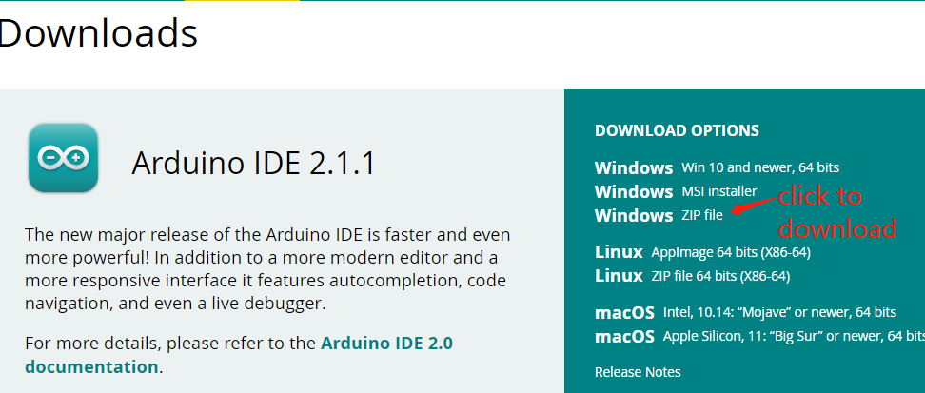

Click to download Windows Zip file

After the download is complete, you will get the compressed package of Arduino IDE 2.1.1.

Unzip it into a folder, open the folder, and double-click the "Arduino IDE" application inside.

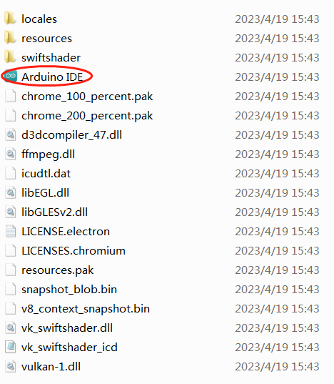

For Windows users, a dialog box prompting "Do you want to install the driver" may pop up during the first run of the IDE software. If it pops up, please allow it to make the driver to be installed.

After the driver installation is complete, a shortcut to the Arduino IDE will be generated on the desktop. Double-click the shortcut to run the Arduino software.

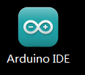

When you run the software for the first time, Arduino will prompt to upgrade the libraries and boards, please click "INSTALL ALL".

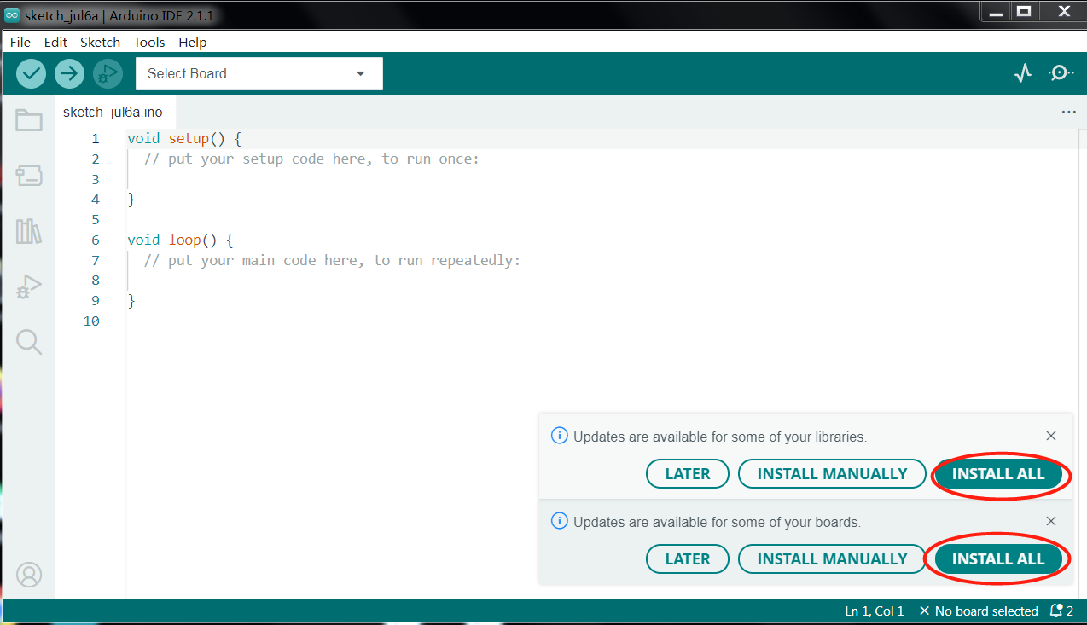

After the libraries and boards are upgraded, the interface of the Arduino software is as follows:

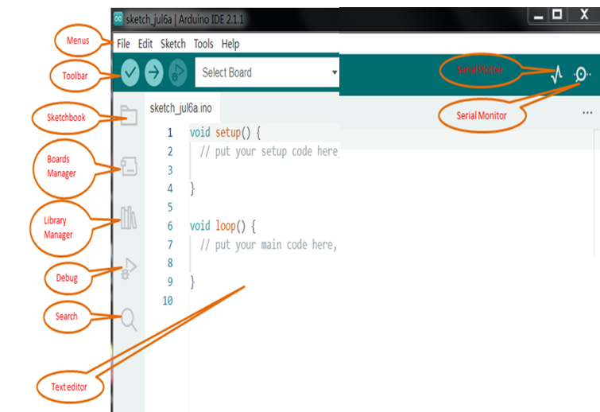

Programs written using Arduino Software (IDE) are called sketches. These sketches are written in the text editor and are saved with the file extension .ino. The editor has features for cutting/pasting and for searching/replacing text. The message area gives feedback while saving and exporting and also displays errors. The console displays text output by the Arduino Software (IDE), including complete error messages and other information. The bottom righthand corner of the window displays the configured board and serial port. The toolbar buttons allow you to verify and upload programs, create, open, and save sketches, and open the serial monitor.

 Verify

Checks your code for errors compiling it.

 Upload

Compiles your code and uploads it to the configured board. See [uploading](https://docs.arduino.cc/software/ide-v1/tutorials/arduino-ide-v1-basics" \l "uploading) below for details.

 Debug

Check for errors in the code (only for some Arduino development boards)

 Boards Manager

You can quickly find the development board you need and install the corresponding package.

 Library Manager

You can quickly query the library you need, and then choose whether to install it or upgrade it according to your needs.

 Serial Monitor

Opens the [serial monitor](https://docs.arduino.cc/software/ide-v1/tutorials/arduino-ide-v1-basics" \l "serial-monitor).

Additional commands are found within the five menus: File, Edit, Sketch, Tools, Help. The menus are context sensitive, which means only those items relevant to the work currently being carried out are available.

# Install the CH340 driver

Most computers have built-in driver or they can install the driver automatically when you first connect the control board of 4wd car to computer. If your computer cannot recognize the control board, please follow this document to install the driver.

# 

**Installing CH340 Driver on Windows PC**

**Check if the driver is installed**

1.Connect your computer and control board of the car with a USB cable.

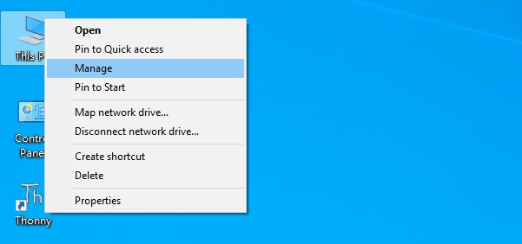2.Go to desktop of your computer, select “This PC” and right-click to select “Manage”.

3.Click “Device Manager”. If your computer has installed the CH340 drive, you can see“USB-SERIAL CH340 (COMx)” in the device manager. This means you don't need to install the driver yourself.

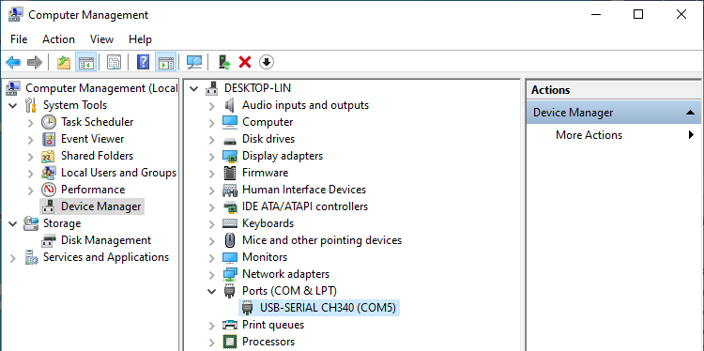

CH340 Port

**Installing Driver for CH340**

## Method 1

1.If your computer fails to automatically install the CH340 driver, you will not see the your device in the device manager, but "USB Serial" with an exclamation point.

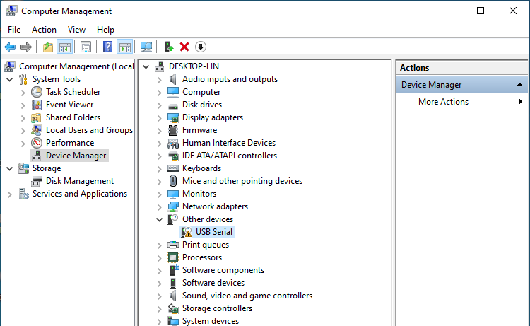

2.Click “USB Serial” and right-click to select “Update driver”.

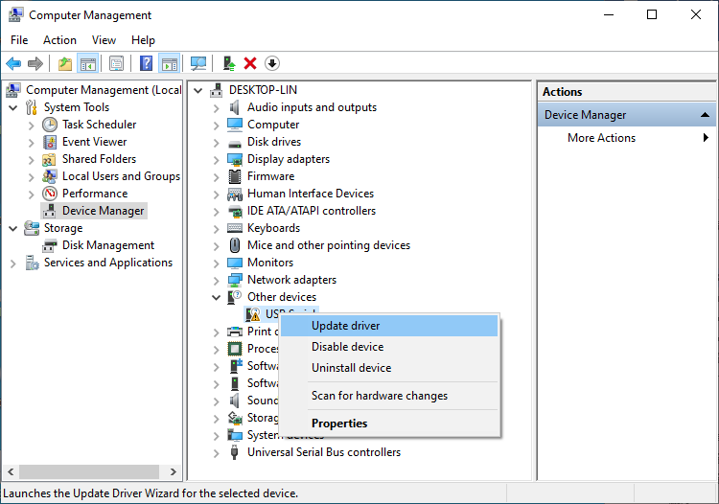

3.Click “Search automatically for updated driver software”.

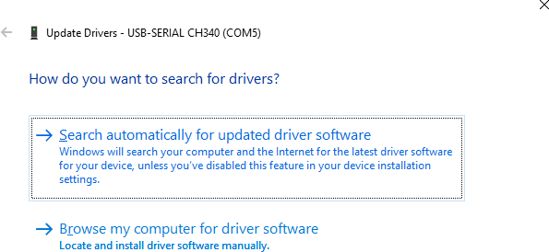

4.Wait for CH340 to finish installation.

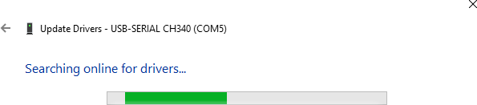

5.When you see the following interface, it indicates that CH340 driver has been installed to your computer. You can close this window.

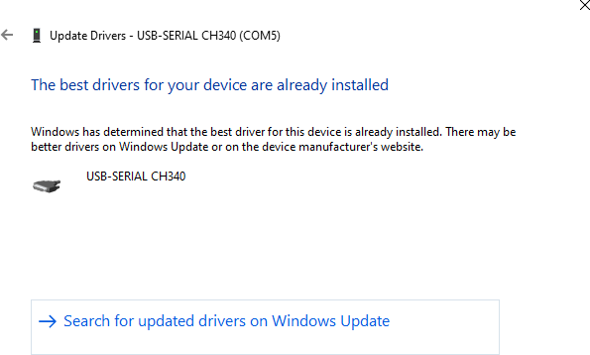

6.If CH340 driver has been installed to your computer, when the control board is connected to your computer, you will see your device name and port number.

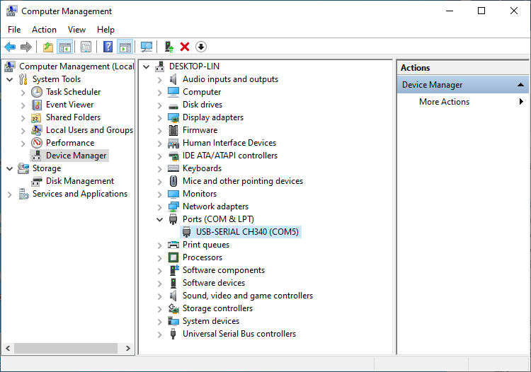

## Method 2

1.First, you need to download CH340 driver,

2.click [http://www.wch-ic.com/search?q=CH340&t=downloads](http://www.wch-ic.com/search?q=CH340&amp;t=downloads) to download the appropriate one based on your operating system.

3.The following figure marks the corresponding drivers for Windows, Linux and Mac computer systems.

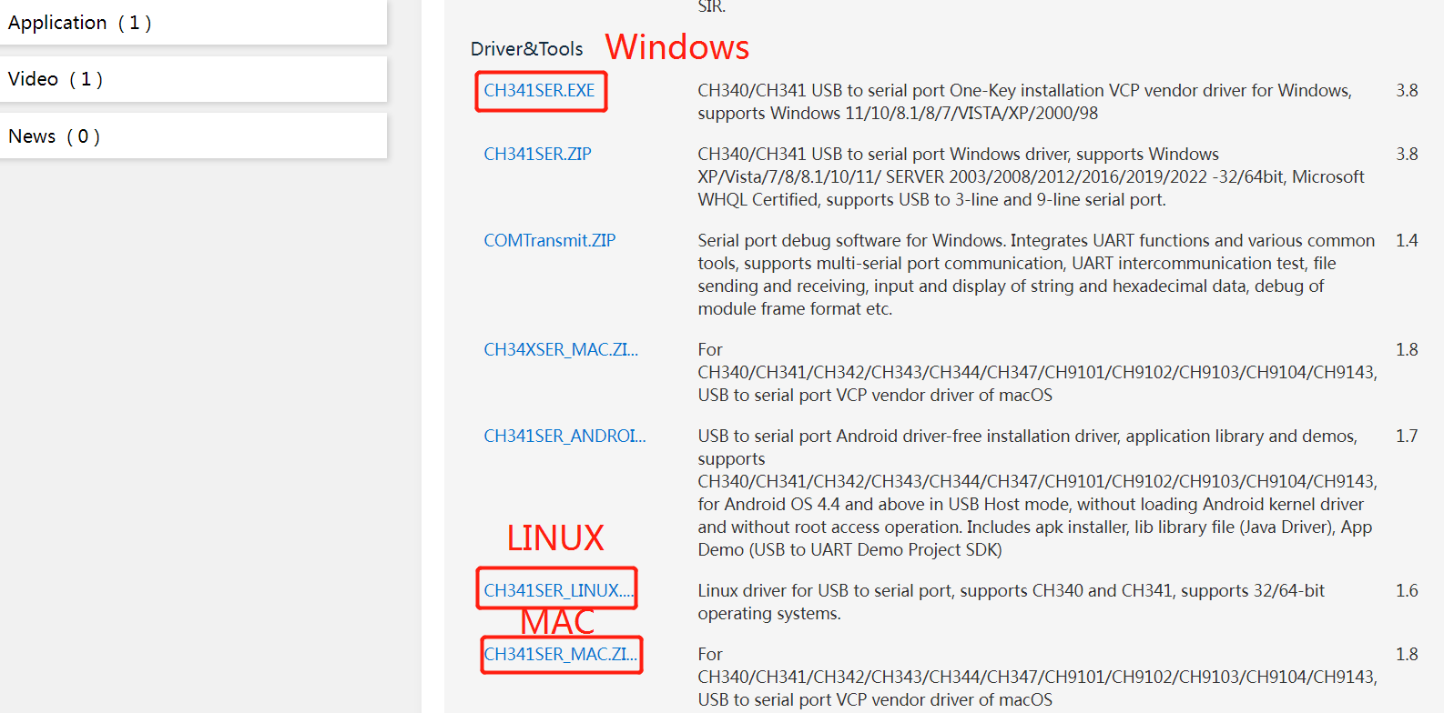

You can also find the installation package in “CH340 Driver” folder which in the “CKK0002-Master”folder you download from the github.



1. Open the folder **“Windows”----“CH341SER”.**

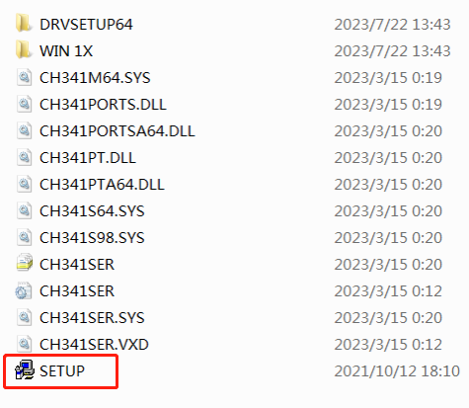

2.Double click “SETUP”.

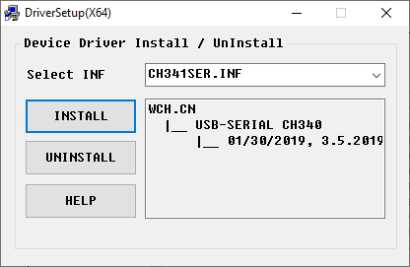

3.Click “INSTALL” and wait for the installation to complete.

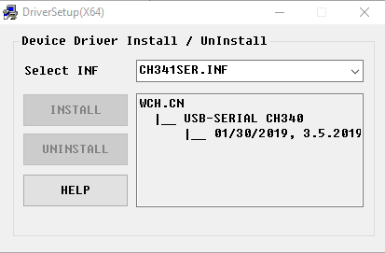

4.Install successfully. Close all windows.

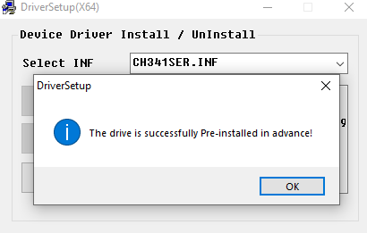

5.When control board is connected to computer, select “This PC”, right-click to select “Manage” and click “Device Manager” in the newly pop-up dialog box, and you can see your device name and port number.



6.So far, CH340 driver has been installed successfully. You can close all dialog boxes.

# Any questions and suggestions are welcome

Thank you for reading this document!

If you find any errors and omissions in the tutorial, or if you have any suggestions and questions, please feel free to contact us at:

**[cokoino@outlook.com](mailto:cokoino@outlook.com)**

We will do our best to make changes and publish revisions as soon as possible.

If you want to learn more about smart cars, robots, learning kits and other technology products from us, please bookmark and pay attention to our website:

<http://cokoino.com/>

We will continue to launch interesting, cost-effective, innovative, user-friendly products.

**LK COKOINO**